BELMONT CITY COLLEGE

Y11 PHYSICS 2013

MOVEMENT TEST 2
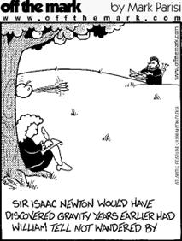

Student name:

_______________________________

35

TIME: 55 minutes

ITEMS Formula & data sheet
Non-programmable calculator

NOTE:

1. Calculations must show clear working with answers stated to three significant figures.
2. Marks will be allocated for clear and logical setting out.
3. To help identify your answer, underline each answer.
4. State assumptions for open-ended types of questions.

1. A rider & bicycle has a combined mass of 87.5 kg which has a change of speed from 3.75 ms⁻¹ to 7.843 ms⁻¹. Calculate and state the gain or loss in kinetic energy.
(2 marks)

2. An electric incandescent light bulb uses 1250 J of electrical energy in 20.0 seconds.
Calculate the power rating of the bulb.
(2 marks)

3. A stationary car of mass 1100 kg is hit from behind by a car of mass 1500 kg travelling north at a constant velocity of 20.0 ms⁻¹. The cars move off independently and the stationary car is pushed northward at a speed of 12.0 ms⁻¹.

Show your working to calculate the velocity of the 1500 kg car after the collision.
(3 marks)

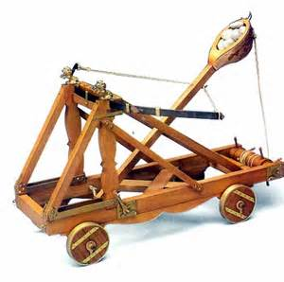

4. A Roman catapult is shown on the right. Such a device typically had a mass of 3 tonnes. It would be loaded with 200 kg of stones and could fire the stones with a forward velocity of 40 m/s.

a) Explain with physics principles why such a catapult recoils backward when it fires the stones forward. (2 marks)

b) Calculate the recoil speed of the catapult. (2 marks)

5. An alpine skier, with a mass of 85.0 kg, is skiing at 16.15 ms⁻¹ on firm snow. Suddenly the skier travels across some fresh snow and experiences a retarding force of 520 N for 1.25 seconds against his motion. After 1.25 s on fresh snow the skier again travels on firm snow.
What is the final speed of the skier when the skier leaves the fresh snow?
(4 marks)

6. In the North of WA there is a design for a tidal power station. During each high tide the sea water storage area can hold 35.6 x 10¹² kg of the salt water. When the tide recedes (low tide) there is an average height difference of 2.12m. As the water flows from the high storage area back to the lower sea level, it is used to drive generators which produce electricity. If this tidal power station is 20% efficient, calculate the amount of energy the station produces from a single high tide.

(3 marks)

7. While on vacation Allison & Shana decide to ride the Roller Coaster of Terror. The roller coaster trolley, with only 2 passengers on board, has a total mass of 280 kg when in operation. At point C the speed of the loaded roller coaster trolley was measured as 10.0 ms⁻¹.
9.50 m
5.50 m
C
A
B
Roller coaster track

a) Show your working and calculate the total energy of the trolley at point C.
(2 marks)

b) While the trolley is travelling from point A, through point B, to point C the associated friction causes a 20% loss of energy. Show your working and calculate the trolley’s speed at point A.
(4 marks)

8. Andrew drives a car with a mass of 1833 kg up a 15.0º slope at a constant velocity of 8.50 ms⁻¹. The car experiences a constant friction of 350 N while travelling up the slope.


θ

a) Draw and label on the diagram to the right all the forces acting on the car.
(2 marks)

b) Calculate the power output of the car when it is travelling at a constant velocity up the slope.
(4 marks)

9. a) During a collision between a car and light truck, a passenger’s head strikes the unpadded dashboard with an average force of 56.0 N for 2.70 x 10 ⁻³ seconds. If a layer of foam padding was used within the dashboard the impact would have lasted for 5.80 x 10 ⁻² seconds. Calculate the average reaction force the padded dashboard would exert.
(3 marks)

b) Explain, using physics terminologies, why car designers put crumple zones at the front of motor cars?
(2 mark)

☺ CONGRATULATIONS: ☺
YOU HAVE COMPLETED THE 2nd Y11 PHYSICS TEST

